*WhileLoop* → **while** *Expression* **:** *Statement* **else** *Statement*

*Expression* → *Expression* **or** *AndExpression* | *AndExpression*

*AndExpression* → *AndExpression* **and** *Term* | *Term*

*Term* → **ID** | **CONST**

*Statement* → *WhileLoop* | **ID** **:=** *Expression* **;**

1. *WhileLoop* →**while** *Expression* **:** *Statement* **else** *Statement*
2. *Expression* → *Expression* **or** *AndExpression*
3. *Expression* → *AndExpression*
4. *AndExpression* → *AndExpression* **and** *Term*
5. *AndExpression* → *Term*
6. *Term* → **ID**
7. *Term* **→CONST**
8. *Statement* → *WhileLoop*
9. *Statement* → **ID :=** *Expression* **;**
10. *WL* → **while** *E* **:** *S* **else** *S*
11. *E* → *E* **or** *AE*
12. *E* → *AE*
13. *AE* → *AE* **and** *T*
14. *AE* → *T*
15. *T* →**ID**
16. *T* → **CONST**
17. *S* → *WL*
18. *S* → **ID :=** *E* **;**

*l0*: *l1*: *goto(l0, WL)* : *l2*: *goto(l0,* **while***)* :

*WL’ →* **.***WL*

*WL →* **.while***E* **:***S* **else***S WL’ →WL* **.***WL →* **while .***E* **:***S* **else***S*

*E →* **.***E* ***or*** *AE*

*E →* **.***AE*

*AE →* **.***AE* ***and*** *T*

*AE* → **.***T*

*T →***.ID**

*T →* **.*CONST***

*l3*: *goto(l2, E)* : *l4*: *goto(l3,***:***)* : *l5*: *goto(l4, S)* :

*WL →* **while***E* **.:***S* **else***S WL →* **while***E* **:.***S* **else***S WL →* **while***E* **:***S* **.else***S*

*E → E* **.or** *AE S →* **.***WL*

*S* → **.ID :=** *E* **;**

*WL →* **.while***E* **:***S* **else***S*

*l6*: *goto(l5,* **else***)* : *l7*: *goto(l6, S)* : *l8*: *goto(l4, WL)* :

*WL →* **while***E* **:***S* **else.***S WL →* **while** *E* **:***S* **else** *S***.***S* → *WL***.**

*S* → **.***WL* **Redukciono - S1****Redukciono - S8**

*S* → **.ID :=** *E* **;**

*WL →* **.while***E* **:***S* **else***S*

*l9*: *goto(l4,* **ID***)* : *l10*: *goto(l9,* **:=***)* : *l11*: *goto(l10, E)* :

*S →* **ID** **.:=***E* ***;*** *S →* **ID****:=.***E* ***;*** *S →* **ID****:=***E* **.;**

*E →* **.***E* **or***AE E → E* **.or***AE*

*E →* **.***AE*

*AE →* **.***AE* **and***T*

*AE →* **.***T*

*T →***.ID**

*T →* **.CONST**

*l12*: *goto(l11,* **;***)* : *l13*: goto(l3, **or**) : *l14*:*goto(l13, AE)*:

*S →* **ID****:=***E* **;.***E → E* **or.***AE E → E* **or***AE***.**

**Redukciono - S9** *AE →* **.***AE* **and***T* **Redukciono - S2**

*AE →* **.***T AE → AE* **.and***T*

*T →***.ID**

*T →* **.CONST**

*l15*: *goto(l2, AE)* : *l16*: *goto(l14,* **and***)* : *l17*: *goto(l16, T)* :

*E → AE***.***AE → AE* **and.***T AE → AE* **and***T***.**

**Redukciono - S3** *T →***.IDRedukciono - S4**

*AE → AE* **.and***T T →* **.CONST**

*l18: goto(l2, T)* : *l19: goto(l2,* **ID***)* : *l20: goto(l2,* **CONST***)* :

*AE → T* **.***T →***ID.***T →***CONST.**

**Redukciono - S5Redukciono - S6Redukciono - S7**

*goto(l4,* **while***)* = *l2 goto(l6,* **while***)* = *l2 goto(l6,* **ID***) = l9 goto(l6, WL)* = *l8*

*goto(l11,* **or***)* = *l13 goto(l10, AE)* = *l15 goto(l10, T)* = *l18 goto(l10,* **ID***)* = *l19*

*goto(l10,* **CONST***)* = *l20 goto(l13, T)* = *l18 goto(l13,* **ID***)* = *l19 goto(l13,* **CONST***)* = *l20*

*goto(l15,* **and***)* = *l16 goto(l16,* **ID***)* = *l19 goto(l16,* **CONST***)* = *l20*

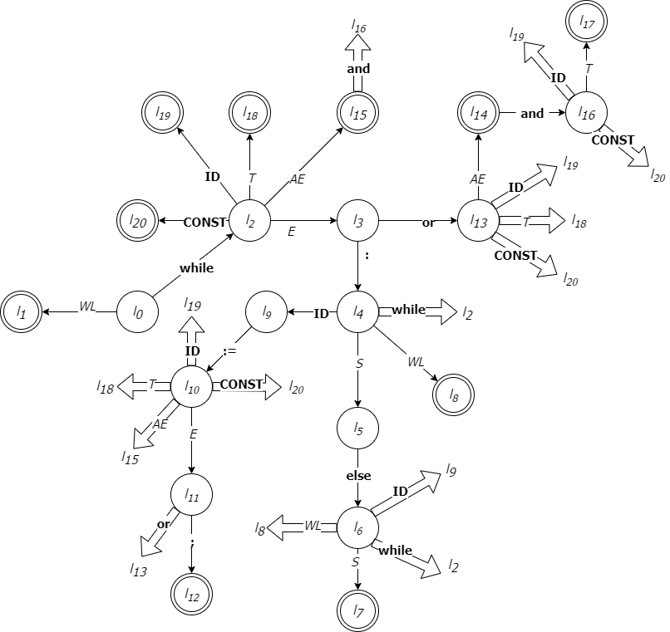

|  |  |  |  |  |
| --- | --- | --- | --- | --- |
| Rbr. Smene | Redukciono  Stanje | Smena  A → α | First(α) | Follow(A) |
| 0. | *l1* | *WL’ →WL* | **while** | **#** |
| 1. | *l7* | *WL* → **while** *E* **:** *S* **else** *S* | **while** | **# else** |
| 2. | *l14* | *E* → *E* **or** *AE* | **ID CONST** | **or : ;** |
| 3. | *l15* | *E* → *AE* | **ID CONST** | **or : ;** |
| 4. | *l17* | *AE* → *AE* **and** *T* | **ID CONST** | **or : ; and** |
| 5. | *l18* | *AE* → *T* | **ID CONST** | **or : ; and** |
| 6. | *l19* | *T* →**ID** | **ID** | **or : ; and** |
| 7. | *l20* | *T* → **CONST** | **CONST** | **or : ; and** |
| 8. | *l8* | *S* → *WL* | **while** | **# else** |
| 9. | *l12* | *S* → **ID :=** *E* **;** | **ID** | **# else** |

|  |  |  |  |  |  |  |  |  |  |  |  |  |  |  |  |
| --- | --- | --- | --- | --- | --- | --- | --- | --- | --- | --- | --- | --- | --- | --- | --- |
|  | AKCIJE | | | | | | | | | | PRELAZI | | | | |
| **while** | **:** | **else** | **;** | **or** | **and** | **ID** | **CONST** | **:=** | **#** | *WL* | *E* | *S* | *AE* | *T* |
| 0 | s2 |  |  |  |  |  |  |  |  |  | 1 |  |  |  |  |
| 1 |  |  |  |  |  |  |  |  |  | acc |  |  |  |  |  |
| 2 |  |  |  |  |  |  | s19 | s20 |  |  |  | 3 |  | 15 | 18 |
| 3 |  | s4 |  |  | s13 |  |  |  |  |  |  |  |  |  |  |
| 4 | s2 |  |  |  |  |  | s9 |  |  |  | 8 |  | 5 |  |  |
| 5 |  |  | s6 |  |  |  |  |  |  |  |  |  |  |  |  |
| 6 | s2 |  |  |  |  |  | s9 |  |  |  | 8 |  | 7 |  |  |
| 7 |  |  | r1 |  |  |  |  |  |  | r1 |  |  |  |  |  |
| 8 |  |  | r8 |  |  |  |  |  |  | r8 |  |  |  |  |  |
| 9 |  |  |  |  |  |  |  |  | s10 |  |  |  |  |  |  |
| 10 |  |  |  |  |  |  | s19 | s20 |  |  |  | 11 |  | 15 | 18 |
| 11 |  |  |  | s12 | s13 |  |  |  |  |  |  |  |  |  |  |
| 12 |  |  | r9 |  |  |  |  |  |  | r9 |  |  |  |  |  |
| 13 |  |  |  |  |  |  | s19 | s20 |  |  |  |  |  | 14 | 18 |
| 14 |  | r2 |  | r2 | r2 | s16 |  |  |  |  |  |  |  |  |  |
| 15 |  | r3 |  | r3 | r3 | s16 |  |  |  |  |  |  |  |  |  |
| 16 |  |  |  |  |  |  | s19 | s20 |  |  |  |  |  |  | 17 |
| 17 |  | r4 |  | r4 | r4 | r4 |  |  |  |  |  |  |  |  |  |
| 18 |  | r5 |  | r5 | r5 | r5 |  |  |  |  |  |  |  |  |  |
| 19 |  | r6 |  | r6 | r6 | r6 |  |  |  |  |  |  |  |  |  |
| 20 |  | r7 |  | r7 | r7 | r7 |  |  |  |  |  |  |  |  |  |